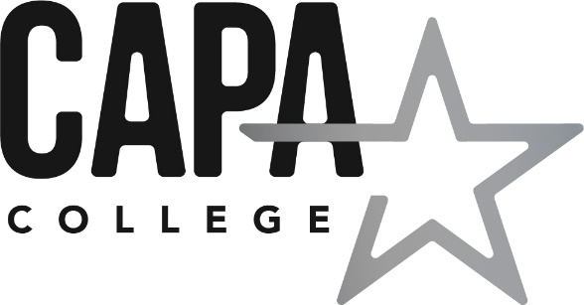

CAPA College Governor Committees

Production Committee (Finance, Personnel and Staffing, Premises and Health and Safety)
Purpose statements:
- To ensure CAPA College has strategic plans in place to deliver effective teaching and learning within CAPA College budget.
- To ensure CAPA College staffing complement supports CAPA College’s aims and ethos and is affordable.
- To ensure CAPA College provides a safe, healthy and sustainable environment for students, staff and visitors.
Membership | Proposed Meeting Dates for 2020/2021
Poonam Kaur (Chair)  Stephen Fealy  Claire Nicholson  Lou O’Brien  Adam Sheard | 20/11/20  26/02/21  11/06/21

Performance Committee
Purpose statement:
To review and evaluate attainment and progress, quality of teaching, curriculum, safeguarding, relevant policies and the implementation of appropriate College development plan priorities.
Membership | Proposed Meeting Dates for 2020/2021
Jo Butterworth  Fiona McMahon  Janet Milne  Claire Nicholson  Lou O’Brien  Pat Thompson | 22/01/21  30/04/21
Principal’s Performance Management Committee
Purpose statement:
To review and evaluate the performance of the College Principal having due regard to the College development plan priorities.
Membership | Proposed Meeting Dates for 2020/2021
Kevin Jones (CEO of Enhance Academy Trust)  Stephen Fealy  Lou O’Brien | November 2020  Review March 2021

There may also be the need to establish ad-hoc Committees or Panels to deal with other matters such as those listed below and the Local Governing Board has been delegated the responsibility to convene these as required, but must have due regard to the relevant policy/procedure these relate to:-
- Admissions
- Admissions Appeals
- Salary Reviews
- Salary Review Appeals
- Grievance Appeals Panel
- Staff Disciplinary Panel
- Staff Disciplinary Appeal Panel
- Student Disciplinary Panel
- Complaints Panel

