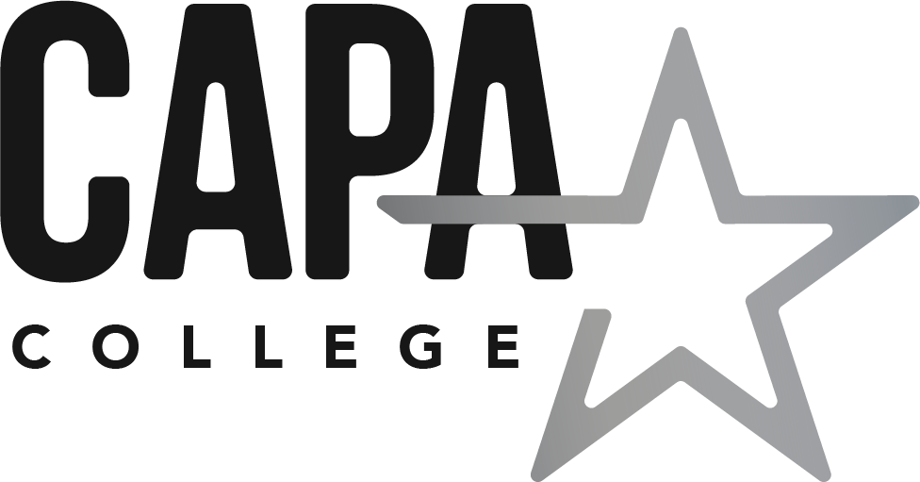

CAPA College
Free School Meals Policy

V2 Approved by Governors: 26th February 2021
Date for Review: February 2022

2021/2022
FREE SCHOOL MEALS

The provision of free school meals is income related. Students of CAPA College will qualify for free school meals if they are aged 16 or over but under 19 on completion of their course and their parent/carer receives:

- Income Support
- Income-based Jobseekers Allowance
- Income-related Employment and Support Allowance (ESA)
- Support under Part VI of the Immigration and Asylum Act 1999
- The guarantee element of State Pension Credit
- Child Tax Credit (as long as you have a yearly household income of less than £16,190 as assessed by HM Revenue and Customs)
- Working tax Credit run-on (paid for 4 weeks after someone stops qualifying for Working Tax Credit)
- Universal Credit with net earnings not exceeding the equivalent of £7,400 p.a. (transitional protection arrangements are in place for those who were eligible for free school meals prior to receiving Universal Credit)

If your child currently receives Free School Meals then your entitlement may continue under the transitional arrangements in place during the roll of Universal Credit if you are able to provide a letter from your Local Authority confirming Free School Meal entitlement.

Please be aware that the following benefits do not qualify for Income Related Free School Meals:

Contributions based jobseeker’s Allowance, Contributions based Employment & Support Allowance, Working Tax Credit, Invalidity Benefit, Disability Living Allowance, Housing Benefit, Council Tax Benefit and Child Benefit.

Students aged 19 or over are only eligible to receive a free school meal if they are continuing a study programme they began aged 16 – 18 or have an Education, Health and Care Plan (EHCP).

If you would like to make a claim for free school meals please complete the attached form and return it to:

CAPA College
Unity House
Westgate
Wakefield
WF1 1EP

We aim to process the application within 5-10 working days and you will be notified of the outcome of your application in writing. CAPA College will ensure that any information you provide is treated in the strictest confidence and handled sensitively.

If your circumstances change, for example, if you start to receive Working Tax Credits or you stop receiving any of the qualifying benefits you must notify CAPA College immediately. If your child receives free school meals whilst they are not entitled, then CAPA College may ask you to pay for the meals provided.

What should I do if I am not happy with the outcome of my application?
Students can appeal against a decision that has been made in relation to their application by writing to:

Mrs L O’Brien
Chair of Governors
c/o CAPA College
Unity Hall
Westgate
Wakefield
WF1 1EP

CAPA College is proud to be a part of Enhance Academy Trust.
Application for Free School Meals

Please fill in all sections so that your child’s eligibility for Statutory Income Related Free School Meals can be verified. You must indicate the benefit(s) you are receiving and evidence of your qualifying benefit(s) must be included for your application to be processed.
Incomplete forms will be returned and this may delay the start date of your claim.
- Your name and address (the person claiming benefits for the family)
Title |  | First Name |  | Surname

Date of Birth |  | National Insurance Number or NASS number

Address

Postcode |  | Tel No

Relationship to child
- Your partner living at the same address
Title |  | First Name |  | Surname

Date of Birth |  | National Insurance Number or NASS number

Relationship to child
- Your child’s details
First Name |  | Surname |  | Date of Birth
- Your benefits
Please complete this section only if your joint family income is £16,190 or under
Please tick (√) if you are in receipt of Working Tax Credit ☐
Please tick (√) the type of benefit you receive
☐ | Income Support | ☐ | Income based Job Seeker’s Allowance
☐ | Income related Employment and | ☐ | Support under Part Vi of the Immigration and Asylum Act 1999
☐ | Child Tax Credit without Working Tax Credit and an annual household income of less than £16,190 | ☐ | Working Tax Credit run-on (paid for 4 weeks after you stop qualifying for Working Tax Credit)
☐ | Guaranteed element of State Pension Credit | ☐ | Universal Credit

- Your benefits – declaration
I agree that CAPA College may use the information I have provided to process my claim for free school meals and will contact other sources as allowed by the law to verify my initial and ongoing entitlement.
I declare that the information given on this form is correct and I will tell you immediately if my details or circumstances change.

Your signature: ………………………………………………………………………………………

Date: …………………

Once completed please send this form to CAPA College Unity House, Westgate, Wakefield WF1 1EP
Important: As soon as your circumstances change, for example, if you start to receive Working Tax Credits or you stop receiving any of the qualifying benefits you must notify us immediately. If your child receives free school meals whilst they are not entitled CAPA College may ask you to pay for meals provided.

General Data Protection Regulations (GDPR)
CAPA College will use the information given on this form for the purpose of processing your application for free school meals. We are under a duty to protect the public funds we handle and may use the information you provide to prevent and detect fraud. We may also share this information for the same purposes, with other organisations which handle public money.

